**Create blob storage and move file from local file s/m to that blob using Terraform:**

**Steps:**

1: Create a main folder. Under that folder create two files

1: main.tf

2: Provider.tf

2: In provider.tf pass and configure the azure provider code:

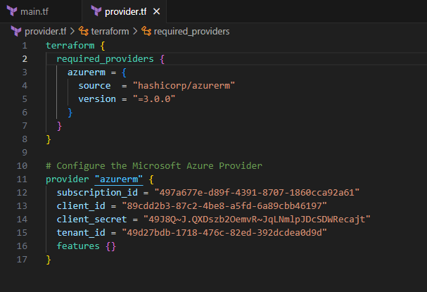

3: In **“main.tf”** enter the code for resource creation.

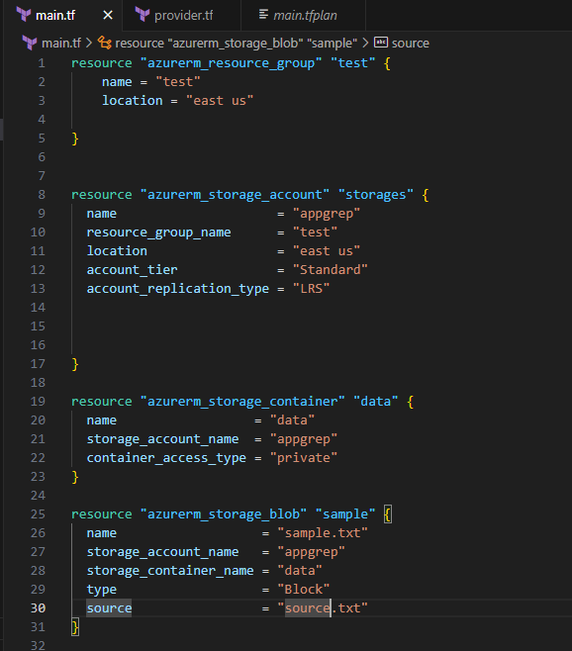

Above main.tf will create:

1. Resource group with name: test
2. Storage account with name: appgrep
3. Container with name: data
4. Blob with name: sample.txt.
5. Copy the file “source.txt” from local file system to the new blob created.

4: Open new terminal and run following commands:

**Terraform init:**

5: **terraform validate:**

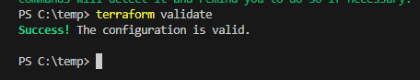

6: **terraform plan:**

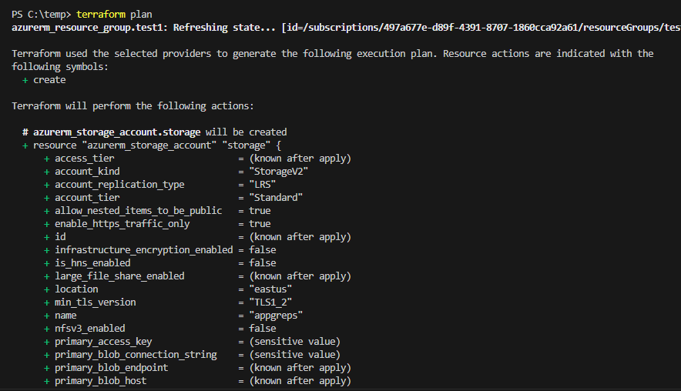

7: Terraform apply:

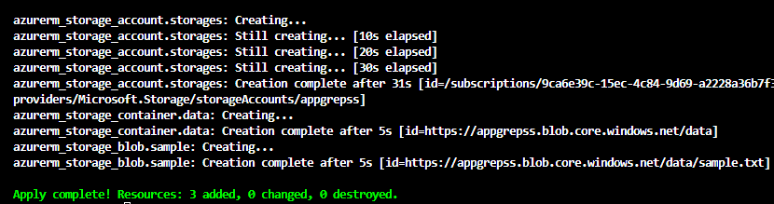

Once Terraform apply is completed, we can verify through azure portal that sample.txt file is created in blob storage.

